Application Deployment Trend Store Project
Phase 1: Created a Ubuntu Server Ubuntu 24.04 LTS AMI with T3.medium and added all the required storage and the open security ports
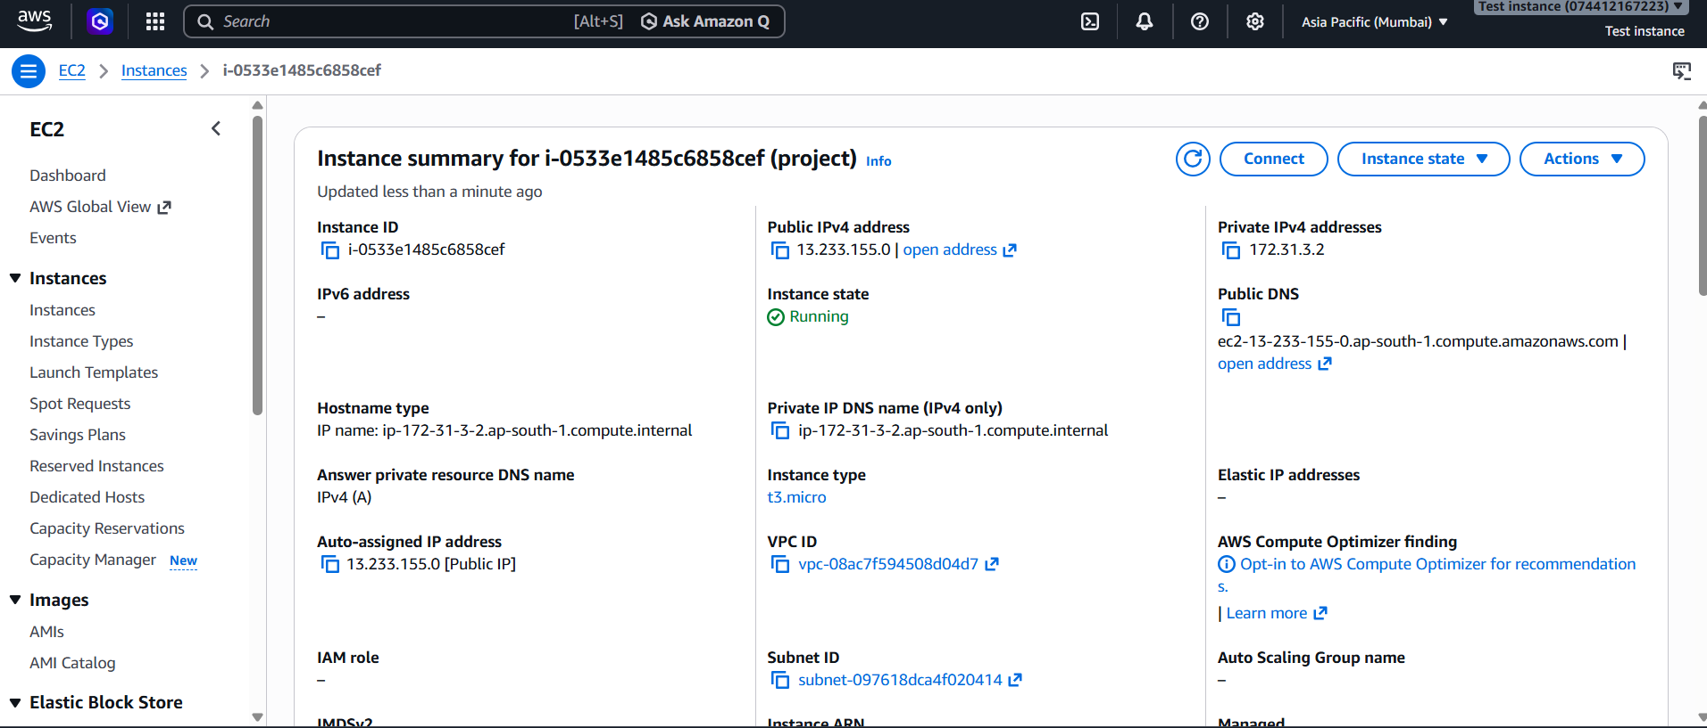
Phase 2: Installed all the applications on the Server
- Java
- Git
- Docker
- Terraform
- AWS CLI
- Kubectl
- Eksctl
- Jenkins
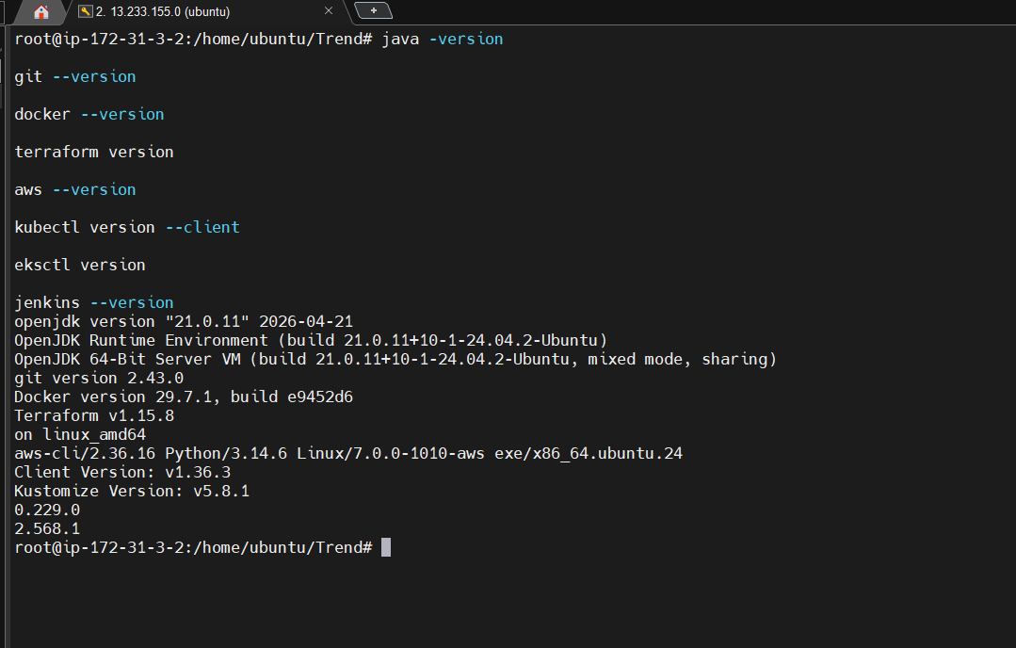
Phase 3: clone the React app for the repo URL and followed the read.me and instructions.
Phase 4: Dockerize Application: created a Docker file, Built image and ran it. Was able to see the trend store accessible.
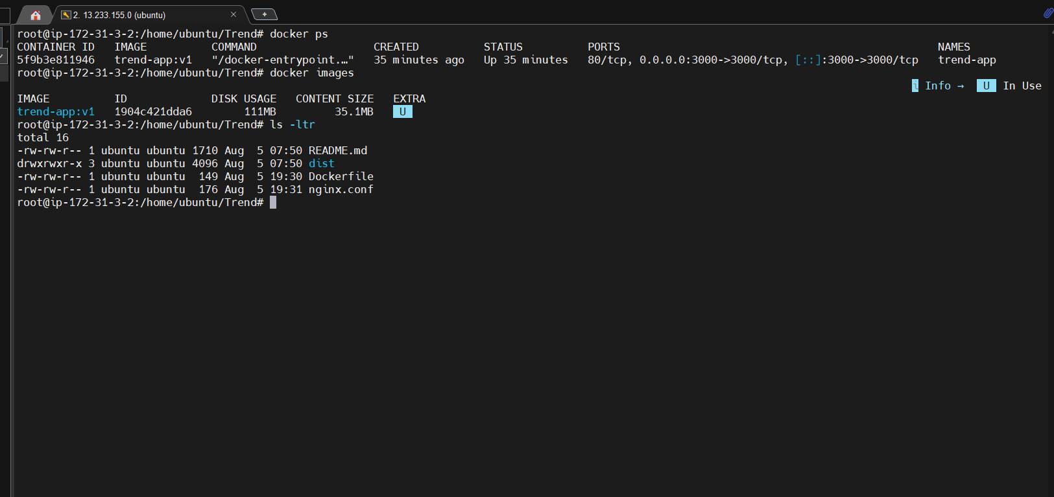

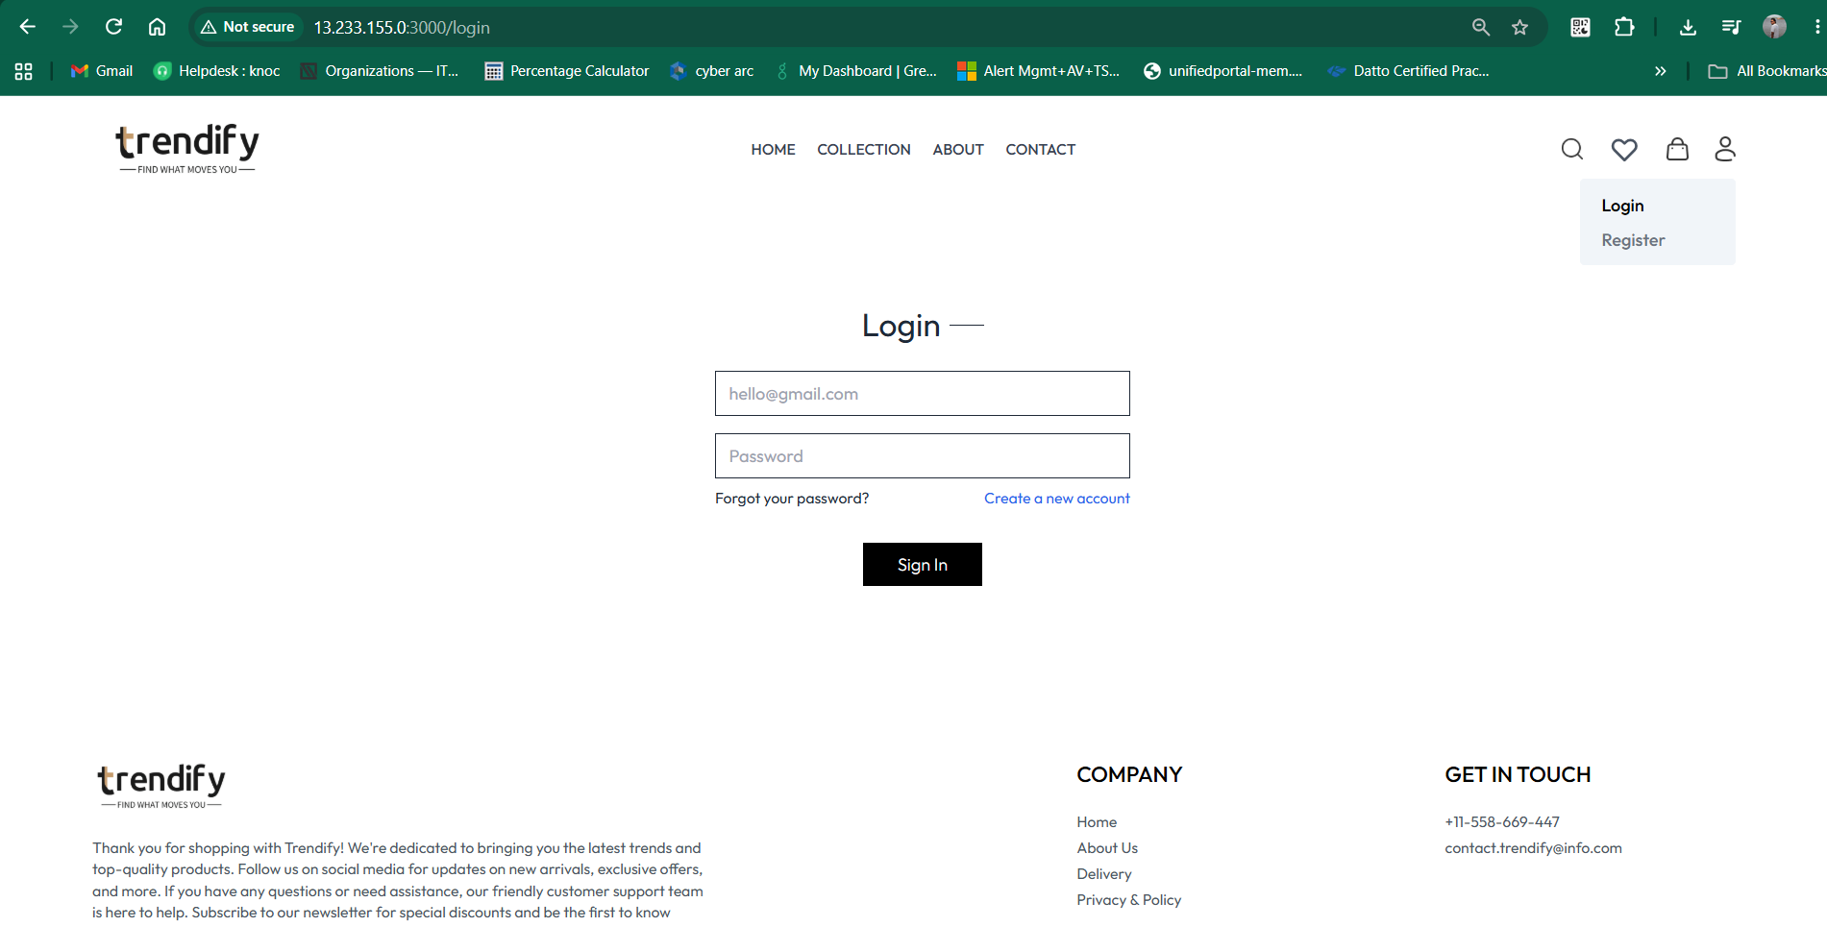

- EKS nodes running and the status shows ready
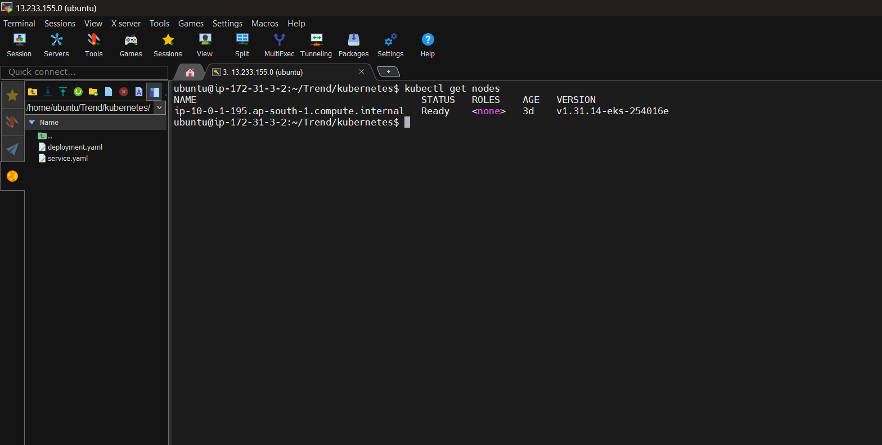
Deployment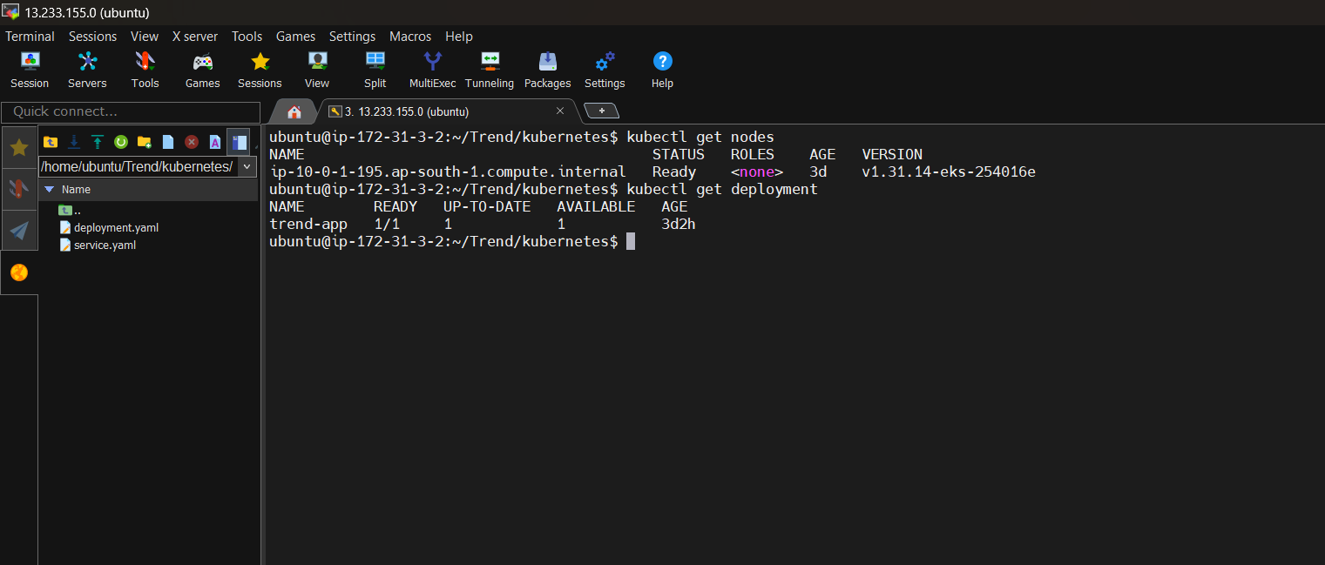
- Pod status running
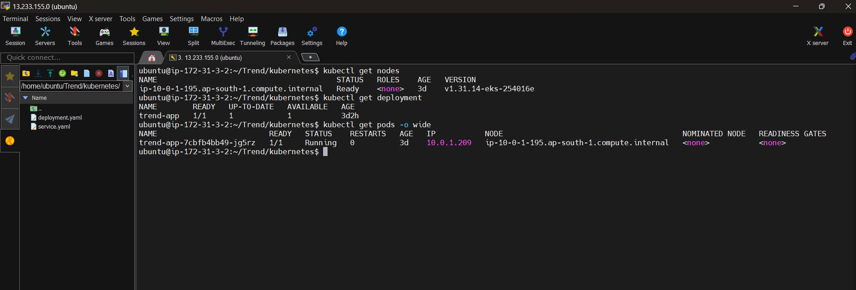

Kubectl svc running
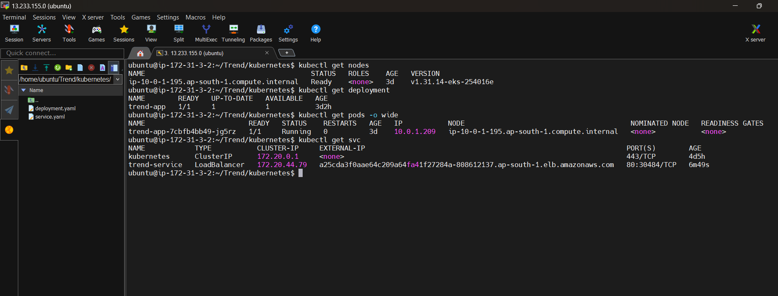

Trend store is accessible:
Kubernetes Service and AWS Load Balancer are now working successfully.
curl -I http://a25cda3f0aae64c209a64fa41f27284a-808612137.ap-south-1.elb.amazonaws.com

Application is accessible from the load balancer DNS
a25cda3f0aae64c209a64fa41f27284a-808612137.ap-south-1.elb.amazonaws.com


- Installed required plugins in the Jenkins site
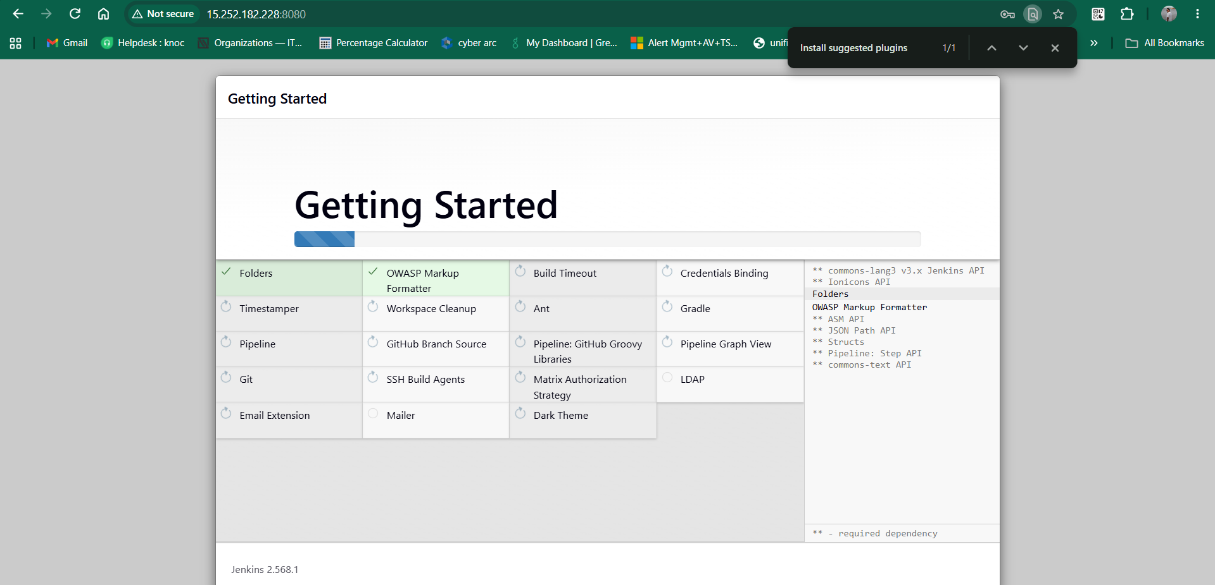
- Perform the 1st build and the built is success full.
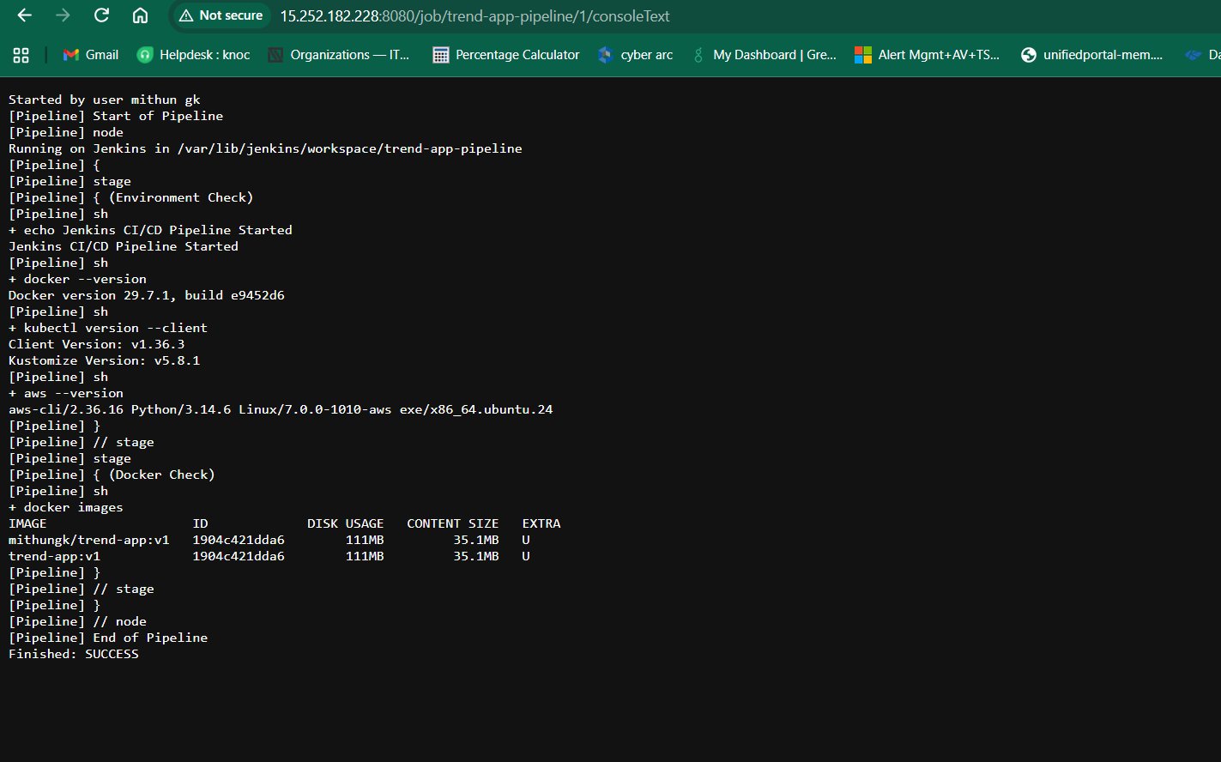
Started by user mithun gk
[Pipeline] Start of Pipeline
[Pipeline] node
Running on Jenkins in /var/lib/jenkins/workspace/trend-app-pipeline
[Pipeline] {
[Pipeline] stage
[Pipeline] { (Environment Check)
[Pipeline] sh
+ echo Jenkins CI/CD Pipeline Started
Jenkins CI/CD Pipeline Started
[Pipeline] sh
+ docker --version
Docker version 29.7.1, build e9452d6
[Pipeline] sh
+ kubectl version --client
Client Version: v1.36.3
Kustomize Version: v5.8.1
[Pipeline] sh
+ aws --version
aws-cli/2.36.16 Python/3.14.6 Linux/7.0.0-1010-aws exe/x86_64.ubuntu.24
[Pipeline] }
[Pipeline] // stage
[Pipeline] stage
[Pipeline] { (Docker Check)
[Pipeline] sh
+ docker images
IMAGE ID DISK USAGE CONTENT SIZE EXTRA
mithungk/trend-app:v1 1904c421dda6 111MB 35.1MB U
trend-app:v1 1904c421dda6 111MB 35.1MB U
[Pipeline] }
[Pipeline] // stage
[Pipeline] }
[Pipeline] // node
[Pipeline] End of Pipeline
Finished: SUCCESS

Also I have added the configuring AWS in the credentials module in the Jenkins. And then ran the new build and got successful.
Started by user mithun gk
Obtained Jenkinsfile from git https://github.com/MITHUNGK18/trend-app.git
[Pipeline] Start of Pipeline
[Pipeline] node
Running on Jenkins in /var/lib/jenkins/workspace/trend-app-pipeline
[Pipeline] {
[Pipeline] stage
[Pipeline] { (Declarative: Checkout SCM)
[Pipeline] checkout
The recommended git tool is: git
using credential mithungk
> git rev-parse --resolve-git-dir /var/lib/jenkins/workspace/trend-app-pipeline/.git # timeout=10
Fetching changes from the remote Git repository
> git config remote.origin.url https://github.com/MITHUNGK18/trend-app.git # timeout=10
Fetching upstream changes from https://github.com/MITHUNGK18/trend-app.git
> git --version # timeout=10
> git --version # 'git version 2.43.0'
using GIT_ASKPASS to set credentials Docker Hub Credentials
> git fetch --tags --force --progress -- https://github.com/MITHUNGK18/trend-app.git +refs/heads/*:refs/remotes/origin/* # timeout=10
> git rev-parse refs/remotes/origin/main^{commit} # timeout=10
Checking out Revision fc6b043091678d02f9a235ddf3911a3c228062dd (refs/remotes/origin/main)
> git config core.sparsecheckout # timeout=10
> git checkout -f fc6b043091678d02f9a235ddf3911a3c228062dd # timeout=10
Commit message: "Fix complete Jenkins CI/CD pipeline"
> git rev-list --no-walk fc6b043091678d02f9a235ddf3911a3c228062dd # timeout=10
[Pipeline] }
[Pipeline] // stage
[Pipeline] withEnv
[Pipeline] {
[Pipeline] withEnv
[Pipeline] {
[Pipeline] stage
[Pipeline] { (Environment Check)
[Pipeline] sh
+ echo ======================================
======================================
+ echo Jenkins CI/CD Pipeline Started
Jenkins CI/CD Pipeline Started
+ echo ======================================
======================================
+ echo Checking Docker...
Checking Docker...
+ docker --version
Docker version 29.7.1, build e9452d6
+ echo Checking kubectl...
Checking kubectl...
+ kubectl version --client
Client Version: v1.36.3
Kustomize Version: v5.8.1
+ echo Checking AWS CLI...
Checking AWS CLI...
+ aws --version
aws-cli/2.36.16 Python/3.14.6 Linux/7.0.0-1010-aws exe/x86_64.ubuntu.24
[Pipeline] }
[Pipeline] // stage
[Pipeline] stage
[Pipeline] { (Build Docker Image)
[Pipeline] sh
+ echo ======================================
======================================
+ echo Building Docker Image
Building Docker Image
+ echo ======================================
======================================
+ docker build -t mithungk/trend-app:v1 .
#0 building with "default" instance using docker driver

#1 [internal] load build definition from Dockerfile
#1 transferring dockerfile: 188B done
#1 DONE 0.0s

#2 [auth] library/nginx:pull token for registry-1.docker.io
#2 DONE 0.0s

#3 [internal] load metadata for docker.io/library/nginx:alpine
#3 DONE 0.9s

#4 [internal] load .dockerignore
#4 transferring context: 66B done
#4 DONE 0.0s

#5 [internal] load build context
#5 transferring context: 3.90kB done
#5 DONE 0.0s

#6 [1/3] FROM docker.io/library/nginx:alpine@sha256:4a73073bd557c65b759505da037898b61f1be6cbcc3c2c3aeac22d2a470c1752
#6 resolve docker.io/library/nginx:alpine@sha256:4a73073bd557c65b759505da037898b61f1be6cbcc3c2c3aeac22d2a470c1752 0.0s done
#6 DONE 0.0s

#7 [2/3] COPY nginx.conf /etc/nginx/conf.d/default.conf
#7 CACHED

#8 [3/3] COPY dist/ /usr/share/nginx/html/
#8 CACHED

#9 exporting to image
#9 exporting layers done
#9 exporting manifest sha256:524c53dc973c636fb779629d67de254979a3e98af668a4cd5e0a4c7456e055a7 done
#9 exporting config sha256:d58bdf5283cc3cc65b13d814de578f8c914aa180bffd35cce11e025ee15fd49f done
#9 exporting attestation manifest sha256:b02e906b80db4cabf25822ffdb7e9f9c43b9daa4e2c2442f8294304ad72b2b57
#9 exporting attestation manifest sha256:b02e906b80db4cabf25822ffdb7e9f9c43b9daa4e2c2442f8294304ad72b2b57 0.0s done
#9 exporting manifest list sha256:fa532f6b690e91ed7c9fca1a16c7812d867f66562adf7aaf7921c988d2fd688f 0.0s done
#9 naming to docker.io/mithungk/trend-app:v1 done
#9 unpacking to docker.io/mithungk/trend-app:v1 0.0s done
#9 DONE 0.1s
+ echo Docker image built successfully.
Docker image built successfully.
[Pipeline] }
[Pipeline] // stage
[Pipeline] stage
[Pipeline] { (Push Docker Image)
[Pipeline] withCredentials
Masking supported pattern matches of $DOCKER_PASSWORD
[Pipeline] {
[Pipeline] sh
+ echo ======================================
======================================
+ echo Logging into Docker Hub
Logging into Docker Hub
+ echo ======================================
======================================
+ echo ****
+ docker login -u mithungk --password-stdin
Login Succeeded
+ echo Pushing Docker image...
Pushing Docker image...
+ docker push mithungk/trend-app:v1
The push refers to repository [docker.io/mithungk/trend-app]
4b496373767b: Waiting
44136fa355b3: Waiting
3cd534fe98c6: Waiting
55afa1ecc21d: Waiting
4b496373767b: Waiting
44136fa355b3: Waiting
3cd534fe98c6: Waiting
55afa1ecc21d: Waiting
4b496373767b: Waiting
44136fa355b3: Waiting
3cd534fe98c6: Waiting
55afa1ecc21d: Waiting
4b496373767b: Waiting
44136fa355b3: Waiting
3cd534fe98c6: Waiting
55afa1ecc21d: Waiting
4b496373767b: Waiting
44136fa355b3: Waiting
3cd534fe98c6: Waiting
55afa1ecc21d: Waiting
4b496373767b: Waiting
44136fa355b3: Waiting
3cd534fe98c6: Waiting
55afa1ecc21d: Waiting
4b496373767b: Waiting
44136fa355b3: Waiting
3cd534fe98c6: Waiting
55afa1ecc21d: Waiting
44136fa355b3: Waiting
3cd534fe98c6: Waiting
55afa1ecc21d: Waiting
4b496373767b: Waiting
4b496373767b: Waiting
44136fa355b3: Waiting
3cd534fe98c6: Waiting
55afa1ecc21d: Waiting
1223f016b4e4: Waiting
62bec68d7c31: Waiting
4b496373767b: Waiting
44136fa355b3: Already exists
3cd534fe98c6: Waiting
55afa1ecc21d: Waiting
55afa1ecc21d: Waiting
1223f016b4e4: Waiting
62bec68d7c31: Waiting
4b496373767b: Waiting
3cd534fe98c6: Waiting
55afa1ecc21d: Layer already exists
1223f016b4e4: Waiting
62bec68d7c31: Waiting
4b496373767b: Waiting
46f977ee452f: Waiting
3cd534fe98c6: Waiting
3cd534fe98c6: Waiting
1223f016b4e4: Waiting
62bec68d7c31: Waiting
4b496373767b: Waiting
46f977ee452f: Waiting
46f977ee452f: Layer already exists
d0008c891db4: Waiting
390dc935348d: Waiting
46519e7231d2: Waiting
4b496373767b: Waiting
3cd534fe98c6: Layer already exists
1223f016b4e4: Layer already exists
62bec68d7c31: Layer already exists
fd9119b18192: Waiting
fd9119b18192: Waiting
d0008c891db4: Waiting
390dc935348d: Waiting
46519e7231d2: Waiting
4b496373767b: Waiting
d87fb1fe9866: Waiting
d0008c891db4: Layer already exists
390dc935348d: Layer already exists
46519e7231d2: Layer already exists
fd9119b18192: Layer already exists
d87fb1fe9866: Waiting
d87fb1fe9866: Layer already exists
4b496373767b: Pushed
v1: digest: sha256:fa532f6b690e91ed7c9fca1a16c7812d867f66562adf7aaf7921c988d2fd688f size: 856
+ echo Docker image pushed successfully.
Docker image pushed successfully.
[Pipeline] }
[Pipeline] // withCredentials
[Pipeline] }
[Pipeline] // stage
[Pipeline] stage
[Pipeline] { (Deploy to EKS)
[Pipeline] withCredentials
Masking supported pattern matches of $AWS_ACCESS_KEY_ID or $AWS_SECRET_ACCESS_KEY
[Pipeline] {
[Pipeline] sh
+ set -e
+ echo ======================================
======================================
+ echo AWS Authentication
AWS Authentication
+ echo ======================================
======================================
+ aws sts get-caller-identity
{
"UserId": "AIDARCU2PSA3VT3BFUOCD",
"Account": "074412167223",
"Arn": "arn:aws:iam::074412167223:user/Project1"
}
+ echo ======================================
======================================
+ echo Configuring EKS
Configuring EKS
+ echo ======================================
======================================
+ aws eks update-kubeconfig --region ap-south-1 --name trend-eks-cluster
Updated context arn:aws:eks:ap-south-1:074412167223:cluster/trend-eks-cluster in /var/lib/jenkins/.kube/config
+ echo ======================================
======================================
+ echo Checking EKS Nodes
Checking EKS Nodes
+ echo ======================================
======================================
+ kubectl get nodes
NAME STATUS ROLES AGE VERSION
ip-10-0-1-195.ap-south-1.compute.internal Ready <none> 3d9h v1.31.14-eks-254016e
+ echo ======================================
======================================
+ echo Deploying Application
Deploying Application
+ echo ======================================
======================================
+ kubectl apply -f kubernetes/deployment.yaml
deployment.apps/trend-app unchanged
+ kubectl apply -f kubernetes/service.yaml
service/trend-service unchanged
+ echo Application deployed successfully.
Application deployed successfully.
[Pipeline] }
[Pipeline] // withCredentials
[Pipeline] }
[Pipeline] // stage
[Pipeline] stage
[Pipeline] { (Verify Deployment)
[Pipeline] withCredentials
Masking supported pattern matches of $AWS_ACCESS_KEY_ID or $AWS_SECRET_ACCESS_KEY
[Pipeline] {
[Pipeline] sh
+ set -e
+ echo ======================================
======================================
+ echo Verifying Deployment
Verifying Deployment
+ echo ======================================
======================================
+ echo Checking AWS Authentication...
Checking AWS Authentication...
+ aws sts get-caller-identity
{
"UserId": "AIDARCU2PSA3VT3BFUOCD",
"Account": "074412167223",
"Arn": "arn:aws:iam::074412167223:user/Project1"
}
+ echo Checking Kubernetes Deployments...
Checking Kubernetes Deployments...
+ kubectl get deployments
NAME READY UP-TO-DATE AVAILABLE AGE
trend-app 1/1 1 1 3d12h
+ echo Checking Pods...
Checking Pods...
+ kubectl get pods
NAME READY STATUS RESTARTS AGE
trend-app-7cbfb4bb49-jg5rz 1/1 Running 0 3d9h
+ echo Checking Services...
Checking Services...
+ kubectl get services
NAME TYPE CLUSTER-IP EXTERNAL-IP PORT(S) AGE
kubernetes ClusterIP 172.20.0.1 <none> 443/TCP 4d15h
trend-service LoadBalancer 172.20.44.79 a25cda3f0aae64c209a64fa41f27284a-808612137.ap-south-1.elb.amazonaws.com 80:30484/TCP 10h
+ echo ======================================
======================================
+ echo Deployment Verification Successful
Deployment Verification Successful
+ echo ======================================
======================================
[Pipeline] }
[Pipeline] // withCredentials
[Pipeline] }
[Pipeline] // stage
[Pipeline] stage
[Pipeline] { (Declarative: Post Actions)
[Pipeline] echo
======================================
[Pipeline] echo
CI/CD Pipeline Completed Successfully!
[Pipeline] echo
======================================
[Pipeline] }
[Pipeline] // stage
[Pipeline] }
[Pipeline] // withEnv
[Pipeline] }
[Pipeline] // withEnv
[Pipeline] }
[Pipeline] // node
[Pipeline] End of Pipeline
Finished: SUCCESS


